**Installation of Samba**

login to your server from root user.

Use below command to install samba with necessary packages.

dnf install samba samba-common samba-client -y

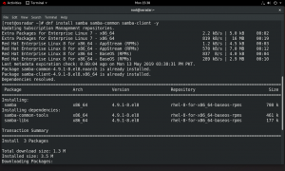

Before configurations, make sure Windows machine is in same workgroup.  
open the cmd prompt in Windows machine and run the following command

> net config workstation

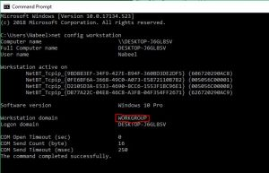

**Samba Configuration**

before configuration rename samba default configuration file /etc/samba/smb.conf as backup.

# mv /etc/samba/smb.conf /etc/samba/smb.conf.default

https://1723336065.rsc.cdn77.org/wp-content/uploads/2019/05/RHEL-8-VM-2019-05-13-15-40-05-300x51.png

**Samba Anonymous File Sharing**

Now create a shared folder on the server where all files/folders will be stored and set appropriate permissions on it and allow SELINUX for the samba configuration.

Run below commands

mkdir -p /srv/samba/anonymous

chmod -R 0755 /srv/samba/anonymous

chown -R nobody:nobody /srv/samba/anonymous

chcon -t samba_share_t /srv/samba/anonymous

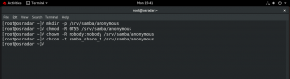

Now make following changes in new samba configuration file.

# vi /etc/samba/smb.conf

[global]

workgroup = WORKGROUP

server string = Samba Server %v

netbios name = rhel8

security = user

map to guest = bad user

dns proxy = no

[Anonymous]

path = /srv/samba/anonymous

browsable =yes

writable = yes

guest ok = yes

read only = no

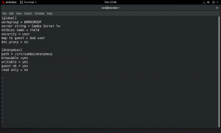

Run below commant to verify samba configurations

TeIf you use the passdb backend = tdbsam default setting, Samba stores

user accounts in the /var/lib/samba/private/passdb.tdb database.

Procedure

Create the operating system account:

# useradd -M -s /sbin/nologin example

This command adds the example account without creating a home directory.

If the account is only used to authenticate to Samba, assign the

/sbin/nologin command as shell to prevent the account from logging in

locally.

Set a password to the operating system account to enable it:

# passwd example

Enter new UNIX password: password

Retype new UNIX password: password

passwd: password updated successfully

Samba does not use the password set on the operating system account to

authenticate. However, you need to set a password to enable the account.

If an account is disabled, Samba denies access if this user connects.

Add the user to the Samba database and set a password to the account:

# smbpasswd -a example

New SMB password: password

Retype new SMB password: password

Added user example.

Use this password to authenticate when using this account to connect to

a Samba share.

Enable the Samba account:

# smbpasswd -e example

Enabled user example.stparm

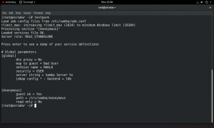

**Start and Add Samba Services in firewall**

Run below command to add samba service in firewall

firewall-cmd --permanent --add-service=samba

firewall-cmd --reload

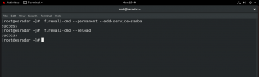

**start and enable samba services**

systemctl start smb.service

systemctl enable smb.service

systemctl start nmb.service

systemctl enable nmb.service

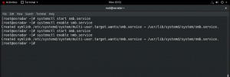

**Access Samba Share Path**

Now open Run prompt by pressing **win + r** key on your keyboard then type **\\rhel8** and press **enter** key.

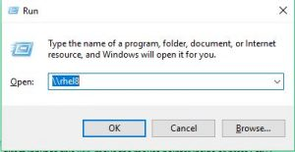

You will see Anonymous folder like below

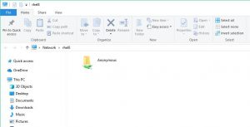

Now you can add files/folders in this folder to share with other users.

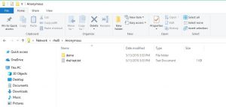

**Create samba secure share**

Create a secured share on the server where only allowed user can login and set appropriate permissions on it and allow SELINUX for the samba configuration.

**Create group for samba users**

groupadd securedgroup

**Create samba user with securedgroup**

useradd demo -G securedgroup

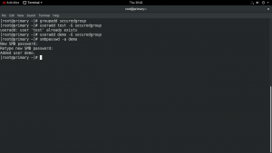

**Now create secure share folder for samba users and set necessary permissions.**

mkdir -p /srv/samba/secured

chmod -R 0770 /srv/samba/secured

chcon -t samba_share_t /srv/samba/secured

chown -R root:securedgroup /srv/samba/secured/

https://1723336065.rsc.cdn77.org/wp-content/uploads/2019/05/RHEL-8-VM-2019-05-16-19-37-02-300x46.png

https://1723336065.rsc.cdn77.org/wp-content/uploads/2019/05/RHEL-8-VM-2019-05-16-19-44-54-300x42.png

**Add user to samba database and set its password**

smbpasswd -a demo

**Now add following lines in samba configuration file.**

vi /etc/samba/smb.conf

[secured]

path = /srv/samba/secured

valid users = @securedgroup

guest ok = no

writable = yes

browsable = yes

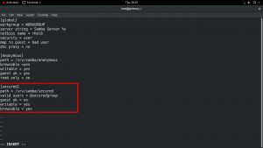

**Then restart samba**

systemctl restart smb.service

**Now access secured share from Windows**

Now you can access the RHEL 8 secured folder from windows, open Run prompt by pressing win + r key on your keyboard  
Then type **\\SAMBA-SERVER-IP** and press enter key.

My samba server IP is 192.168.130.152 so i will use **\\192.168.130.152  
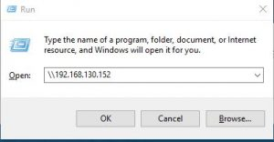**

Now Click on secured folder and it will ask you to enter samba user login details to access the folder.  
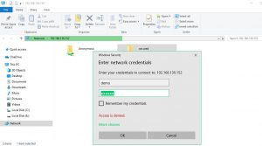

You will see secured folder like below, Now you can add files/folders in this folder to share with other samba users.

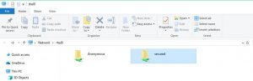

**Mount and access Samba secure share from Linux**

I am going to use **Ubuntu** to access RHEL 8 Samba secure share.  
Login to Ubuntu, open terminal and run below command.

**First install samba client**

apt-get install samba-client -y

**Now use below command to verify Samba Share is accessible.**

smbclient --user=demo -L //192.168.130.152

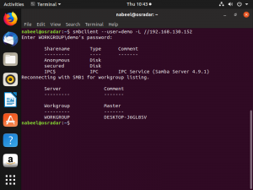

Command Syntax:  
smbclient –user=samba-username -L //Samba-Server-IP

**Access/Mount Samba share**

smbclient //192.168.130.152/secured -U demo

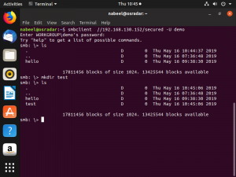

Command Syntax:  
smbclient //Samba-Server-IP/share-name -U samba-username

That’s it you have accesses the samba shared from Windows and Linux successfully.